**Network Programming for Engineers (ECE 5650)**

**Lab5**

**Team Members Names: Anika Tasnim & Li Lin**

Q1. What is the IP address of your computer?

Answer: IP address of my computer is 192.168.0.21

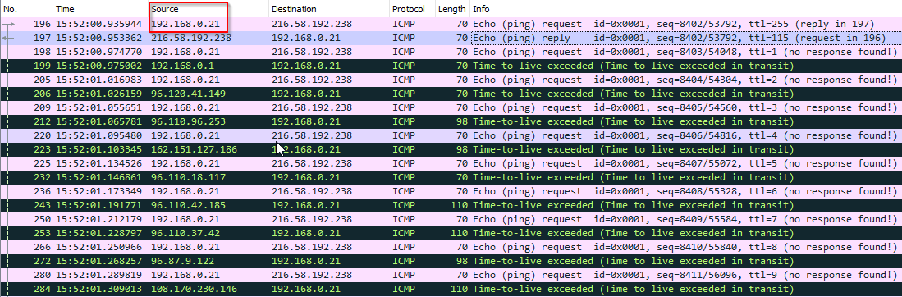

Q2. Within the IP packet header, what is the value in the upper layer protocol field?

Answer: It is ICMP protocol

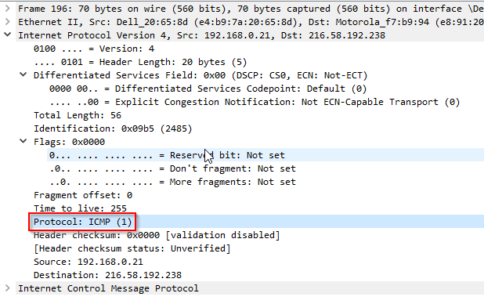

Q3. How many bytes are in the IP header? How many bytes are in the payload *of the IP datagram*? Explain how you determined the number of payload bytes.

Answer:

IP header has 20 bytes in total.

Payload = 36 bytes = total length 56 bytes - header length 20 bytes

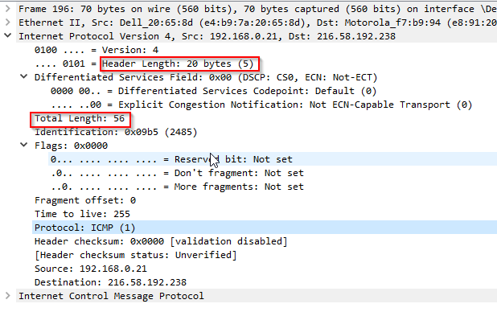

Q4. Has this IP datagram been fragmented? Explain how you determined whether or not the datagram has been fragmented.

Answer:

This IP datagram is not fragmented. Firstly, this is the first datagram, secondly in Flags, More fragments bit is not set. So this is whole datagram not fragmented. And the identification of next IP datagram are different.

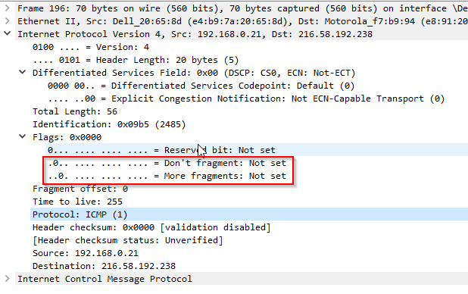

Q5. Which fields in the IP datagram *always* change from one datagram to the next within this series of ICMP messages sent by your computer?

Answer:

1. Checksum is changing
2. Identification is changing
3. TTL is changing

Q6. Which fields stay constant? Which of the fields *must* stay constant? Which fields must change? Why?

Answer:

1. Version, Header length, protocol, source address and destination address stay constant
2. Version, protocol, source address and destination address must stay constant
3. Identification must change. Because each different datagram have different identification.

Q7. Describe the pattern you see in the values in the Identification field of the IP datagram

Answer:

Each Identification value of the IP datagram sent from my computer are increased by 1 sequentially.

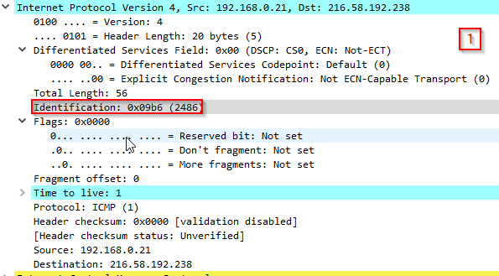 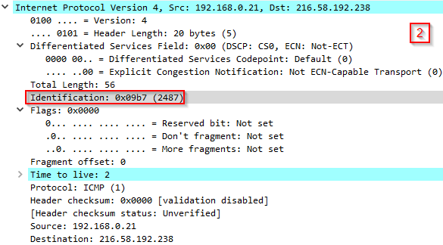

Next (with the packets still sorted by source address) find the series of ICMP TTL exceeded replies sent to your computer by the nearest (first hop) router.

Q8. What is the value in the Identification field and the TTL field?

Answer:

Identification is 0x07CF

TTL = 64

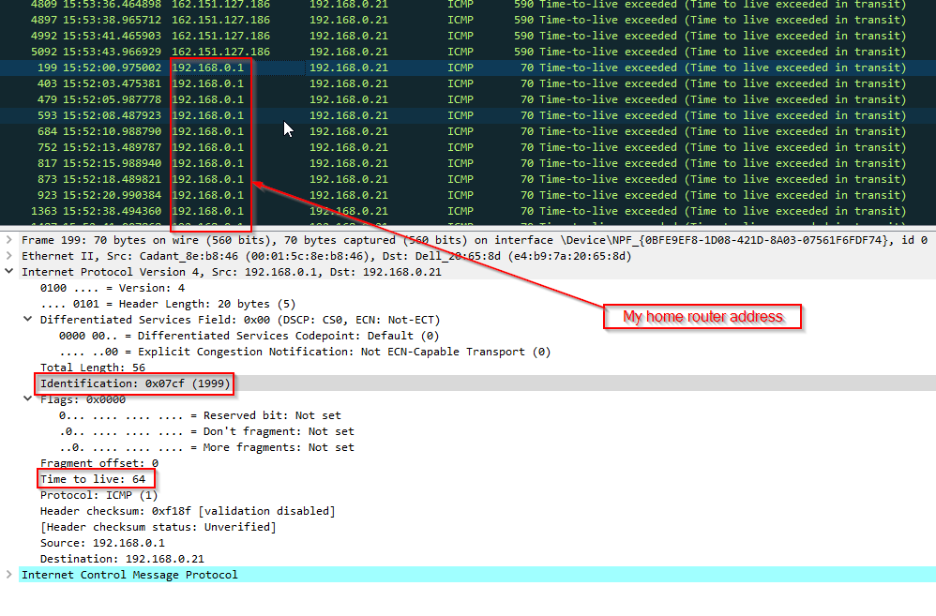

Q9. Do these values remain unchanged for all of the ICMP TTL-exceeded replies sent to your computer by the nearest (first hop) router? Why?

Answer:

Yes, they are all same. Because they all come from my home router.

Q10. Find the first ICMP Echo Request message that was sent by your computer after you changed the *Packet Size* in *pingplotter* to be 2000. Has that message been fragmented across more than one IP datagram?

Answer:

No.1359 datagram is the first ICMP Echo request message. It is fragmented. From below figure, the fragment offset is 1480.

The identification is 0x0a21 which is same as previous IPv4 datagram’s identification which is first part of the 2000 bytes packet. See Q11 screenshot

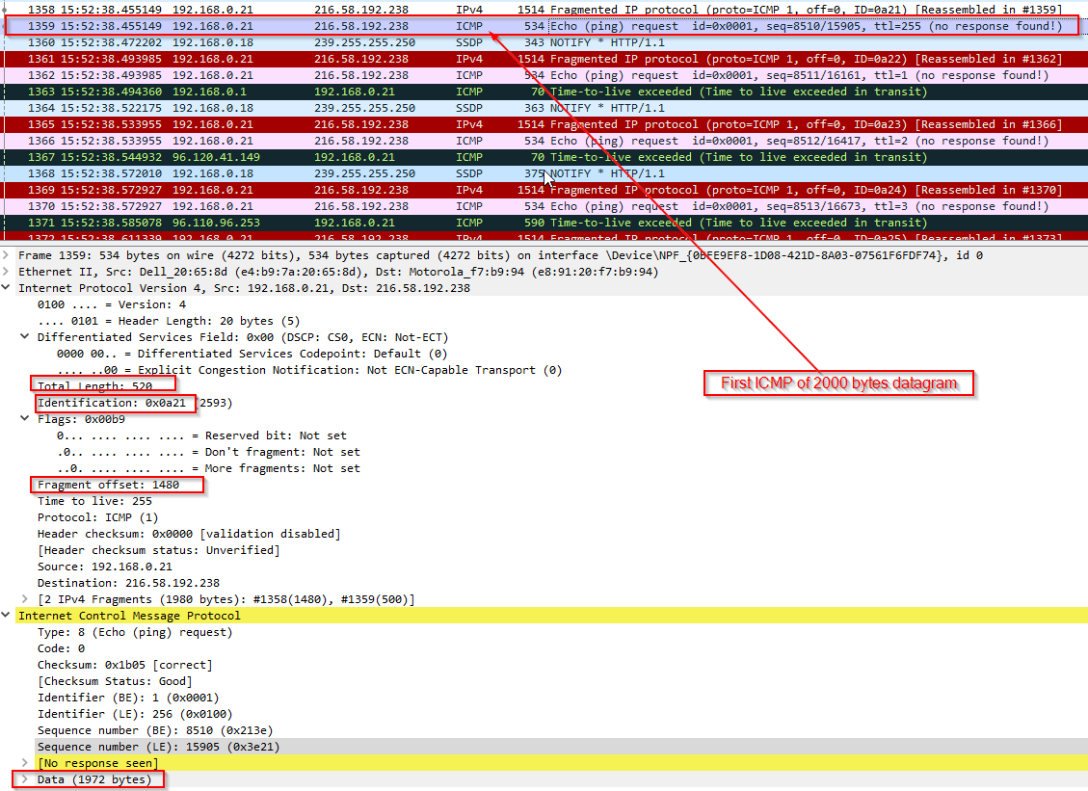

Q11. Print out the first fragment of the fragmented IP datagram. What information in the IP header indicates that the datagram been fragmented? What information in the IP header indicates whether this is the first fragment versus a latter fragment? How long is this IP datagram?

Answer:

In Flags field, More fragments bit is set which means this datagram is fragmented. The fragment offset is 0 which means this is the first fragment.

This IP datagram is 1500 bytes including 1480 bytes payload and 20 bytes header

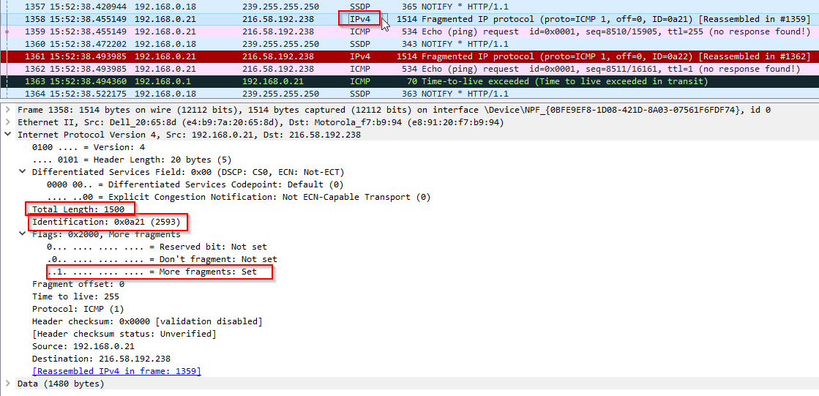

Q12. Print out the second fragment of the fragmented IP datagram. What information in the IP header indicates that this is not the first datagram fragment? Are the more fragments? How can you tell?

Answer:

The fragment offset indicates this is not the first datagram fragment. This is the last fragment because the More fragments is 0(Not set)



Q13. What fields change in the IP header between the first and second fragment?

Answer:

More fragments bit in Flags field

Total length

Fragment offset